
Qwwdq

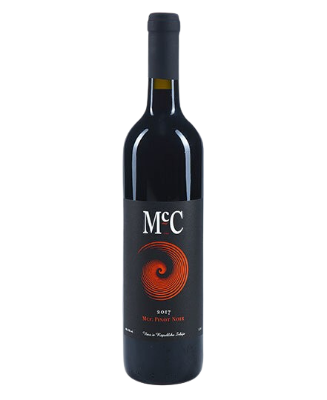
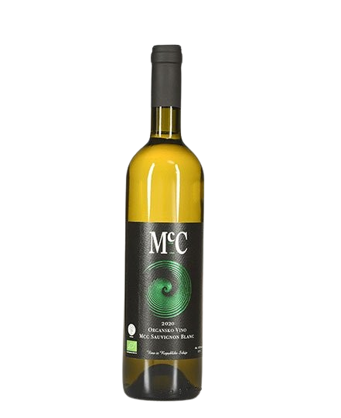
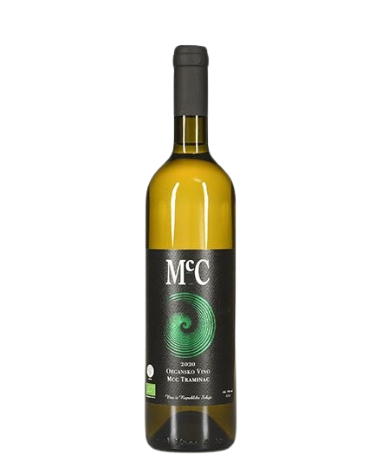
Pino Noar
- Dry red wine -

About the vine

Grape variety:
- Pinot Noir
Origin: Erdevik, Fruška Gora
Serving temperature:14-16 ºC

A wine with pronounced varietal characteristics, balanced and fruit-driven, featuring red fruit aromas complemented by notes of cinnamon, peppermint, and green tea. Through aging, additional nuances of minerality, vanilla, and sweet oak have developed.
It is aged for 18 months in oak barrels, followed by at least 10 months in bottle.
Food pairing includes grilled salmon and other fish, steak, chicken (especially when cooked in red wine), fried and braised lamb, dishes where mushrooms are a key flavor component, pheasant, duck, and similar dishes. The best matches are simple yet richly flavored ingredients.
We produce an average of only around 300 bottles of Pinot Noir per year. However, it is highly valued and reserved for our best customers. Although produced in limited quantities, it can be found at several select retail locations.

